A
Project Stage-I Report On
“Design And Fabrication Of Automatic AAC(autoclave aerated concrete ) Batching Plant”
Submitted to
Savitribai Phule Pune University, Pune
In partial fulfillment of the requirements for the award of degree of
Bachelor of Engineering in Mechanical Engineering

Submitted By
Jadhav Shubham Thorat Omkar
Jadhav Vasant Thorat Shubham
Guide
Pro. A. A. Kamble
Dept. of Mechanical Engineering
JSPM Narhe Technical Campus , Narhe ,Pune

2021 -22

DECLARATION

This Thesis entitled “Design and fabrication of automatic AAC batching plant” is our own work carried out under the guidance of Prof. A. A. Kamble, Department of Mechanical Engineering, JSPM Narhe Technical Campus, Narhe, Pune. This work in the same form or any other form is not submitted by us or anyone else for the award of any degree.

Jadhav Shubham
Thorat Omkar
Jadhav Vasant
Thorat Shubham

Date :

ACKNOWLEDGEMENT

We take this opportunity with a great pleasure to express our sincere regards and deep sense of gratitude to our guide Prof. A. A. Kamble, Assistant Professor in mechanical engineering department, JSPM NTC, Pune for his valuable guidance, practical suggestions and encouragement to bring about the completion of project.
It is through his proficient knowledge, valuable guidance and support that this project report has been set right.
We are also thankful to all faculty of Mechanical Engineering Department of JSPM NTC, Pune who have always co-operated while carrying out the project work.
We also express gratitude towards Dr. M. A. Kumbhalkar, Head of Mechanical Engineering (II Shift) and Dr. Sumant Choudhari , Director, JSPM NTC, Pune for their encouragement and timely suggestions.
Finally, we would like to thank our well wishers, critics who helped directly or indirectly in the completion of this work.

Jadhav Shubham
Thorat Omkar
Jadhav Vasant
Thorat Shubham
JSPM NARHE TECHNICAL CAMPUS, NARHE, PUNE
DEPARTMENT OF MECHANICAL ENGINEERING
CERTIFICATE
This is to certify that
Jadhav Shubham Thorat Omkar
Jadhav Vasant Thorat Shubham

has successfully completed the Project Stage –I entitled “Design and fabrication of Automatic AAC batching Plant” under my supervision, in the partial fulfillment of Bachelor of Engineering - Mechanical Engineering of Savitribai Phule Pune University, Pune during the session 2021-2022.
Date :
Place :
Prof. A. A. Kamble  Guide |  | Prof. K. S. Rambhad  Internal Examiner
INDEX
CHAPTER NO | TITLE | PAGE NO
 | ABSTRACT | 7
CHAPTER 1 | INTRODUCTION | 8
 | PROBLEM STATEMENT | 10
 | OBJECTIVE | 10
 | SCOEPE | 11
 | METHODOLOGY | 11
CHAPTER 2 | LITERATURE REVIEW | 12
CHAPTER 3 | DESIGN CALCULATION | 19
 | CALCULATION | 19
 | DESIGN DATA | 25
CHAPTER 4 | ELECTRICAL ACTUATORS AND CONTROL PANEL SYSTEM | 28
CHAPTER 5 | CONCLUDING REMARKS & SCOPE FOR FUTURE WORK | 31
 | CONCLUSION | 31
CHAPTER 6 | REFERENCES | 32
LIST OF FIGURES
FIGURE NO. | FIGURE NAME | PAGE NO.
1 | CURRNT SYSTEM OF BATCHING PLANT | 25
2 | MODEL OF HOPPER STAND | 25
3 | HOPPER FOR STORAGE OF AL. POWDER | 27
4 | HOPPER FOR STORAGE OF GYPSUM POWDER | 27
5 | STORAGE TANK OF SOLUBLE OIL | 28
6 | CYLINDRICAL FLASK OF AL. POWDER | 28
7 | CYLINDRICAL FLASK OF GYPSUM POWDER | 28
8 | FINAL VIEW OF PROJECT | 30

ABSTRACT
AAC block or Light weight blocks are the new generation technology in construction field. Higher strength, Light weight and lower construction time make the AAC Block beneficial than conventional clay bricks. AAC blocks are manufactured by using raw material like Fly-ash, Lime cement gypsum aluminum soluble oil, the mass ratio of above material is very important to achieve required strength. Current system uses manually measuring the raw material and then discharging into the mixer, hence it increases the uncertainty in recipe. We are tackling this problem with Design and Fabrication of Automatic AAC Batching Plant. This will lead to increase accuracy and repeatability of recipe. We are going to use pneumatic and electric solenoid valves system for automation. Main aim of this project is to implement this automatic system without affecting the existing one. This will definitely beneficial for the AAC block manufacturing industry.

Keywords:- AAC system – Batching system – raw materials – Design- fabrication – automatic system-conclusion

CHAPTER 1
INTRODUCTION
- What is AAC block?
- AAC (Autoclaved Aerated Concrete) was invented in the mid-1920s by the Swedish architect and inventor Johan Axel Eriksson. AAC is one of the major achievements of the 20th century in the field of construction. It is a lightweight, precast building material that simultaneously provides structure, insulation, and fire resistance. AAC Blocks is a unique and excellent type of building materials due to its superb heat, fire and sound resistance. AAC block is lightweight and offers ultimate workability, flexibility and durability
- Fly ash, water, lime, cement, aluminium powder, and gypsum are among the main constituents. Cement strength is used to provide block hardness, and autoclaving is used to achieve rapid curing. Gypsum is an excellent long-term strength builder. The chemical reaction that occurs as a result of The porous structure, lightness, and insulating qualities of AAC are all due to aluminium paste. Unlike other lightweight concrete materials, this one is absolutely unique. The finished item is When compared to traditional bricks, this Block is 2.5 times lighter while maintaining the same strength. The specific gravity ranges between 0.6 to 0.65. This is the most unique feature of the AAC blocks. because the builder saves 30 to 35 percent on materials by using these blocks in structural constructions.
Advantages:
- Consumes Fly ash, which is a big problem for thermal power plants to dispose. It is environment friendly, because of no need of burning.
- Higher strength, best thermal insulation & excellent sound absorption, vibration resistance compared to red bricks. The AAC product’s lightweight and easy workability means that is very quick to install on site and transportation with lesser
breakage.
Production Procedure of AAC plant:
The AAC Plant in which Fly-ash mixed with water after then it is discharge in slurry hopper through mud pump. As well as lime and cement transfer in its hopper through screw conveyor. This all materials taken in main mixer along with aluminium , gypsum powder and soluble oil it made mixture.
After the mixture making procedure it is feeding in the available mould box and it is kept for pre-curing and that’s stage occurring chemical reaction due to aluminium and lime reaction with water and this mixture increase in size like cake. After the pre-curing stage remove the top of the moulds by using Demoulder. After the demoulding it is give for cutting in proper sized blocks through horizontal and vertical cutting machine and then it is forward in the autoclave system for curing in high steam pressure and temperature. After this procedure AAC blocks are ready to sell.
Following is the tree chart of block making procedure.

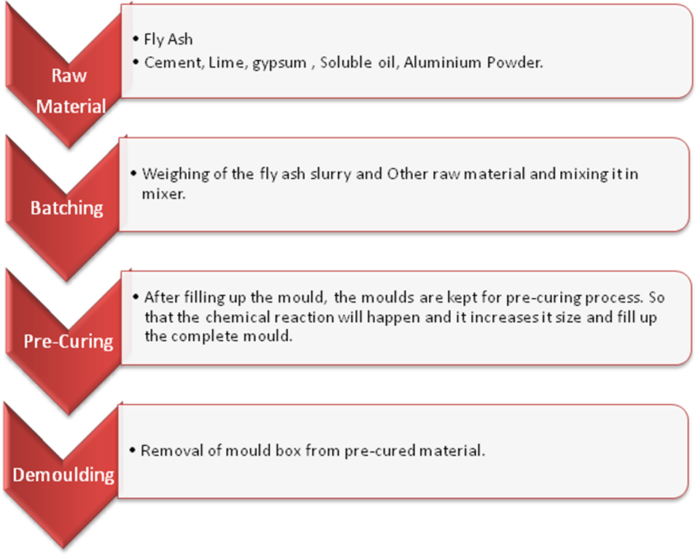
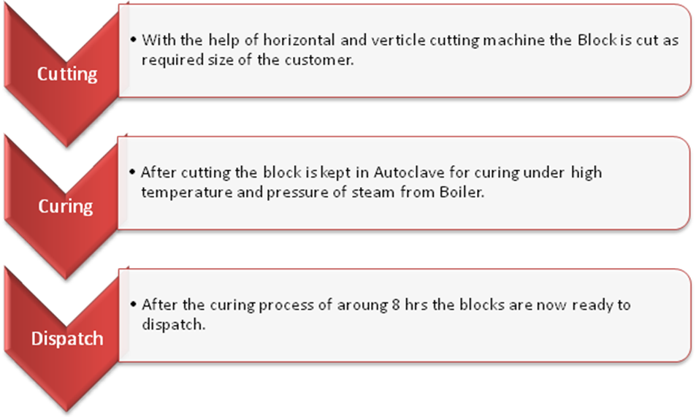
  - Problem Statement :
- Raw materials in which cement , lime , slurry and water feeding in main mixer by automatic system and its operated through control panel but there is aluminium , gypsum powder and soluble oil is feeding manually by labours.
- There is three raw materials feeding manually process and its associated with human errors.
- In this batching system each time raw materials like aluminium, gypsum and soluble oil feeding repeatedly by manual process that’s why there processing time is not constant.
- Above problem are associated with the batching(mixing) system of AAC plant which will lead to poor quality of blocks and damaged block.

  - Objective:
- Minimizing the human interaction.
- Optimize the production time
- Application of system without altering the current system and without affecting quality of blocks.
From the above point we are increase the speed of production rate and avoide the poor quality of blocks.

  - Scope:

  - Autoclaved Aerated Concrete (AAC) is a non combustible, lime based, cementitious building material that is expanding into new worldwide markets. now a days Use Of AAC block significantly increase due to low cost and easy structure. Builder and developer set up their own AAC block Plant instead of buying .
  - We are making this automatic batching system for aac plant is beneficial for all old plants.

  - Methodology:

•Study of existing system and scope of application of new parts.

•Study on raw material required for production.
•Design of automatic system for raw material feeding (aluminium, gypsum and
Soluble oil)
•Fabrication of design parts.
•Installation of fabricated parts in current system.
•Validation of installed parts.

CHAPTER 2

LITERATURE REVIEW

1. Kamal Arif M. (2016), Autoclaved Aerated Concrete (AAC): A Sustainable Building Material [Online] Available from http://www.masterbuilder.co.in/autoclaved-aerated-concrete-aaca-sustainable-building-material/, accessed on 10 May 2020.
The traditional bricks are the main building materials that are used extensively in
the construction and building industry. Autoclaved Aerated Concrete blocks are recently one of the newly adopted building materials. The Autoclaved aerated concrete (AAC) is a product of fly ash which is mixed with lime, cement, and water and an aerating agent. The AAC is mainly produced as cuboid blocks and prefabricated panels. The Autoclaved aerated concrete is a type of concrete that is manufactured to contain lots of closed air voids. The AAC blocks are energy efficient, durable, less dense, and lightweight. It is manufactured by adding a foaming additive to concrete in different sizes of molds as per requirement, then wire-cutting these blocks or panels from the resulting ‘cake lump’ and ‘heating them with steam. This process is called as Autoclaving. It has been observed that this material is an eco-friendly building material that is being manufactured from industrial waste and is composed of non-toxic ingredients. In this paper, an overview of AAC blocks with reference to its potential and sustainability as a novel building material has been presented. The paper also presents a comparative cost analysis of AAC Blocks with the Red clay bricks and its suitability and potential use in the construction in the building industry.
2.J.L. Amoros, G. Mallol, E. Sanchez, J. GarciaInstituto de Tecnologfa Ceramica (ITC)Asociaci6n de Investigaci6n de las Industrias Ceramicas (AICE)Universitat Jaume I. Caste1l6n. Spain.[ Online] available https://www.qualicer.org
In ceramic tile, frit and ceramic colour production processes, large quantities of particulate solids of different nature are handled, which need to be adequately stored and discharged. On discharging these materials, flow stoppages as a result of doming in the bin, size segregation, etc. can occur. Some of these problems can be minimised and even suppressed by appropriate bin design. In this study, the [enike theory has been applied to bin design for three types of particulate materials: spray-dried powder, used in porcelain tile manufacture, zinc oxide and quartz, used inceramic frit production. For these materials the maximum angle that the wall needs to form with the vertical in the bin discharge zone, and the minimum outlet diameter required for appropriate ,unbroken material flow during discharge were calculated. The influence was also analysed of the bin surface on the type off low. Finally, experiments were conducted to verify the usefulness of the methodology test for bin design.

3.Rocky A. Sabigoro aster Thesis LIU-IEI-TEK-A--14/01794—SED partment of Management and Engineering Division of Fluids and Mechatronic Systems Linköping UniversitySE-581 83 Linköping Sweden January. [online] available https://www.diva-portal.org

Within Li U Fluid laboratory there had been a number of hydraulic and pneumatic test stands for research projects and teaching. The effort was needed to do more extension within the field of pneumatics. This thesis was about designing, manufacturing, building and testing the Test Stand for vertical application of pneumatic rod less cylinder. It consisted of three main parts; mechanical structure, pneumatic system and electrical and electronics. The design part focused more on the mechanical structure and pneumatic system. Electrical and electronics had to be installed to facilitate actuation and control of the system after mechanical and pneumatic components were assembled together. The mechanical structure consisted of three main parts; cabinet, carriage and ball balancer. For each part three concepts were generated, evaluated and selected to obtain the most promising concept for further development.

4. Praveen Kumar B1, Bhashavena Shushma2, Dr. B.Vijaya Kumar3 1Associate Professor, 2Assistant professor, 3Professor Mechanical Engineering, Guru Nanak Institute of Technology, Telangana, India .[online] available https://troindia.in

This Paper Proposes is to design a magnetic actuator to deal with the modeling and
optimization of Solenoid actuator (Magnetic Actuator). The design is very important step for the study proportional solenoid valve. The magnetic actuator includes design and optimization, characterization one of the magnetic actuator. This benefits the design optimization of the spherical actuator greatly. According to the magnetic field model, the variation of flux density with respect to pole of the magnet parameters can be revealed. Therefore, these parameters can be appropriately chosen to achieve a high magnetic flux density. Since all these magnetic actuators work in sub- micron level movement used in micro system and valve applications. Proportional solenoid valve designed in find out the magnetic force (N), magnetic field intensity (A/m), magnetic flux
density (Tesla or wb/m2). To enhance the magnetic force and reduction of size by magnetic field in air gap of solenoid valve. Permanent magnetic bias magnetic actuator study for bidirectional application using different permanent magnet material and optimization of size of armature.

5. KONG Xiao wuand LI Shizhen The State Key Lab of Fluid Power Transmission and Control, Zhejiang University, Hangzhou 310027, China Received August 16, 2013; prevised April 29, 2014; accepted May 13, 2014[online] available http://cjme.springeropen.com

The methods of improving the dynamic performance of high speed on/off solenoid valve include increasing the magnetic force of armature and the slew rate of coil current, decreasing the mass and stroke of moving parts. The increase of magnetic force
usually leads to the decrease of current slew rate, which could increase the delay time of the dynamic response of solenoid valve. Using a high voltage to drive coil can solve this contradiction, but a high driving voltage can also lead to more cost and a decrease of safety and reliability. In this paper, a new scheme of parallel coils is investigated,
in which the single coil of solenoid is replaced by parallel
coils with same ampere turns. Based on the mathematic model of high speed solenoid valve, the theoretical formula for the delay time of solenoid valve is deduced. Both the theoretical analysis and the dynamic simulation show that the effect of dividing a single coil into N parallel sub-coils is close to that of driving the single coil with N times of the original driving voltage as far as the delay time of solenoid valve is concerned. A specific test bench is designed to measure the dynamic performance of high speed on/off solenoid valve. The experimental results also prove that both the delay time and switching time of the solenoid valves can be decreased greatly by adopting the parallel coil scheme. This research presents a simple and practical method to improve the dynamic performance of high speed on/off solenoid valve.

6. 1Sandip Patel, 2Vishant Patel1PG Student, 2Assistant Professor
Laljibhai Chaturbhai Institute of Technology, Bhandu [online] available http:// www.ijsdr.org

Bulk storage tanks are very important for industrial and agricultural facilities. The value of these tanks to society exceeds by far the economic value of the tanks and their contents. This is because the failure of tanks and their accessories not limited to the immediate danger to nearby human lives, but also to a large extent leads to serious consequences and very likely to long-term environmental damages. Thus to prevent failure of the silo it must be design properly. This report contents designing of the silo as per various applicable code and standards. The silo is designed for various types of load acting on it e.g. dead load, live load, wind or seismic load, load during filling and discharging of bulk material etc. Stress calculation has been done for Silo having storage capacity of 580 m3 for storing plastic pellets. Thi include different kind of stresses developed in silo i.e. circumferential stress, axial stress, equivalents stresses. Finally, all stresses are verified by allowable stress values of construction material according to standards. Axial buckling and circumferential buckling stresses are verified as per DIN 18800 part 4 199

7. M. Jimenez ´ 1 · E. Kurmyshev1 · C.E. Castaneda ˜ 1Received: 7 July 2018 / Accepted: 10 January 2020© The Author(s) 2020 [online] available https://doy.org
In this article, the dynamics of a double-acting pneumatic actuator was experimentally studied. To understand the details of dynamics and provide experimental data for further modeling and numerical simulation of actuators, a special test bench was designed. The bench includes a high-resolution linear encoder as well as a d SPACE 1104 data acquisition board, that permits high-frequency sampling to identify important features in the measured data at different source pressures; it also incorporates two pressure sensors, a solenoid valve, a push button, and a measuring interface to automate the acquisition of data. High precision measurements of the time of displacement and position of the moving elements, piston rod or cylinder body, allowed us to calculate velocity and acceleration. We found that the velocity of the moving element is near constant ina major part of the stroke. The recording of the dynamics of upstream and downstream pressures in the pneumatic cylinder chambers at different source pressure levels permitted us to calculate the force exerting by the piston and to explain the kinematics of the moving element. The matching of the upstream and downstream pressure plots with the displacement of the moving element allowed us to establish the instant when the moving starts, and this way evaluates such an important featureas the static friction force between the piston and cylinder body. Various scenarios were used in the experiments, including the fixing of the piston rod, which allow the cylinder body to move or vice versa, the horizontal or vertical position of the pneumatic cylinder and the forward or backward stroke movement. The results obtained with the proposed experimental bench provide essential information on the dynamics of a double-acting pneumatic cylinder that can be included in the mathematical model of the cylinder and used in mobile robotics.

8. Anurag Wahane1Civil Department, Columbia Institute of Engineering & Technology, Raipur, (India) [online] available www.ijarse.com

AAC blocks are light weight Aerated Autoclave Concrete Block. It is manufactured through a reaction of aluminium powder and a proportionate blend of lime, cement, and fly ash or sand. Autoclaved aerated concrete
(AAC) is a lightweight cellular concrete that has been used for more than 80 years. Currently, however, no good recycling options for AAC from construction and waste exist. During this process, the hydrogen gas escapes create lots(billions) of tiny air cells, applying AAC with a strong cellular structure. The hydrogen gas or bubbles cause the concrete to expand to roughly thrice times its original volume, further strengthened by high pressure steam curing. The product thus formed is not only light weight concrete but also has higher compressive strength. AAC is a masonry material that is lightweight, easy to construct, and economical to transport. AAC is one of the materials which can cope up with the shortage of building raw materials and can produce a light weight, energy efficient and environmentally friendly concrete. This study deals with the manufacturing process of the autoclaved aerated concrete blocks.

9. 1Abhilash Diliprao Jachak,2Dr. S.G. Makarande,3Pro A.B. Dehane,4Pro. M.M. Lohe1 Mtech Student ,2Professor,3Professor,4Professor1Mtech Structural Engineering,1Bapurao Deshmukh College Of Engineering, Sevagram, India [online ] available www.ijcrt.org

In order to compete in the ever growing competent market it is very important for a structural engineer to save time. As a sequel to this an attempt is made to analyze and design a multistoried building by using a software package STADD PRO. As
STAAD Pro is the current leading design software in the market, many structural designing companies use this software for their project design purposes. So, this article mainly deals with the analysis of the results obtained from the design of a building structure when it is designed using STAAD Pro Software. The software method of analysis is used for a G+5 Residential building with ACC in fill material used first is brick infill, second is AAC block infill. So there for two types of infill material in which 6 models will be prepared in STAAD Pro. In this study G+5 storey building is considered for analysis which is located in zone IV earth quake region and zone II. Static analysis is done
using pro software, soil conditions is to be medium and importance factor is to be taken as 1.2. various parameter studied like lateral displacement of building axial load in column, storey drift, storey shear, base shear, moments diagrams for a particular beam
for all two types of material and for all cases and weight calculations as per code IS 1893.

10. Miroslav Sokol, Pavol Galajda, Martin Pecovsk ˇ y, Stanislav Slov ´ ak´Dept. of Electronics and Multimedia CommunicationsTechnical University of Kosice ˇ
Park Komenskeho 13, 040 01 Ko ´ sice , Slovakia miroslav. sokol, pavol. galajda, martin. pecovsky, [online] available https://ieeexplore.ieee.org

This article describes a design of two-stage differential amplifier with Cherry-Hooper amplifier stage and simple differential amplifier stage. The amplifier structure is designed
and fabricated in 0.35 µm Si Ge Bi CMOS technology and has been designed for 17 GHz bandwidth with 13 dB single-ended gain. The amplifier is powered by -3.3 V power supply with power consumption 550 mW. Time domain large signal single-ended output swing achieves 650 mVpp. The amplifier is primarily
designed as a sensing element for specialized M-sequence couple antenna structure but is also suitable for output stage and UWB radar sensor applications.

11. Wenke Kang, Changde Lu, Xiaojie Gao, Minjiu YuSchool ofindustrial design department Northwestern Polytechnical University, [online ] available https://ieeexplore.ieee.org

Based on Ergonomics and the basic requirements of control panel design, this paper studied the computer-aided design method based on man-machine principle restraint with control panel modeling, color and other man-machine elements being chosen as
research subjects. The study realized the restraint design from the product structure to size, amelio ratedthe human machine interactive relationship from the aspect of human physiological and psychological demands and improved the comprehensive quality of
control panel.

12. Ching-hai YANG*, Sunao KAWAI*, Yukio KAWAKAMI**Kenji, SINOZAKI, Tadahiro MACHIYAMA Department of Mechanical Engineering , Waseda Universit
[online] available https://www.researchgate.net

A pneumatic diaphragm motor controlled by two PWM solenoid valves are studied . First, the characteristics of the PWM solenoid valve is investigated and a simplified mathematical model of the valve is presented . Second, a PWM control law is synthesized by considering the effects of the valve characteristics and the asymmetrical flow characteristics between the charging process and the discharging process of the system. The main parameters that influences the performance of the system are analyzed and their values are optimized experimentally . At last, the frequency response and the stiffness characteristics of the proposed system are obtained and the results show that the performance of the proposed system is better than the traditional one. These experiments verify the theoretical design work, and indicate that the PWM controlled pneumatic diaphragm motor is feasible for practical use.

13. Chengtao Xu1, Ying Zhou1, Shengnian Cai1, Ran Qin1, Yu Liang1, Baolin Pang1
Shenyang University of Chemical Technology Shenyang,110142,China. [online ] available http://ieeexplore.ieee.org

A Solenoid valve Operating Life test system based on PLC was developed in order to examine the reliability and durability of a certain type solenoid valve, In this paper , not only structure and principle of the test system, but also hardware and
Software design of the test system were illustrated in detail. The really applied result show that the test system can control test parameters quickly and accurately with features of high degree of automation, good reliability and easy to operate .And the test system
provides a high-effect testing and researching platform for the development of high-performance Solenoid valves.

14. Hrituraj Singh Rathore1, Dr.Savita Maru2 1M. E Student - Department of Civil Engineering, Ujjain Engineering College, Ujjain, Madhya Pradesh2Professor - Department of Civil Engineering, Ujjain Engineering College, Ujjain, Madhya Pradesh
[online] available www.ijraset.com

Autoclaved Aerated Concrete is a Low cost, Lightweight, Load- bearing, High-insulating, Durable building product, which is produced in a wide range of sizes and strength and used widely due to its low cost in earthquake prone area. In this study a 3D numerical model of AAC and Brick fully infill building and buildings having soft storey is constructed and performed the analysis by using software SAP 2000 (ver.16.0) using static nonlinear method. This paper highlights the comparing and investigating the changes in structural behavior of AAC and Brick fully infill and building having soft storey subjected to seismic load. The result of the analysis for displacement base shear and storey drift have been studied and compared for all the structure models.
15. Júlio César Mendes Lobato, juliocm@ufpa.brAlexandre Luiz Amarante Mesquita, alexmesq@ufpa.brAndré Luiz Amarante Mesquita, andream@ufpa.brFederal University of Pará, Institute of Technology, Postgraduate Program in Mechanical Engineering , Augusto Correa Street, 01, Guamá, Belém-PA, Brazil, Zip code 66075-110. [online] available https://www.reserchgate.net

In many cases problems in silos may occur due to improper design of its geometry due to no consideration of The flow properties of the material. One of the factors that affect the flow properties of materials is the moisture content, which allows the formation of cohesive arches in the material inside the silo avoiding the desirable mass flow
type. Therefore, this paper aims to analyze the flow properties of the product red mud, for different moisture, in order to provide a mass flow in conical silos. Initially, the flow properties of red mud are determined by laboratory testing
using the Jenike cell, and then the design of the silo hopper is performed using Jenike and Enstad theories, i. e. the minimum diameter and angle of inclination of the hopper are determined for each moisture level. In order to validate the theoretical results, experimental results were obtained in laboratory for red mud powder using silos with different hoppers.

CHAPTER 3

3.1 . Design calculation

calculation of raw material required for 1 day to 5 day in AAC block manufacturing Plant for 20 cubic capacity
find out the raw material requirement for per day to for AAC block manufacturing plant 20 cubic meter
In 20 cbm production completed in 20 cycle each cycle is perform work in 1 cubic capacity.
1) for 1 cb m production requirement of raw material
1. Aluminium powder.=350 gm
2.gypsum=7000gm
Soluble oil=500ml
2) for 20 cbm/per day required is
350 ×20= 7000 gm = 7 kg
7 X 20 =140kg
500 ×20=10 lit

Also, we have to design System to store this material upto 5 days
For 5 days material required for
Al powder= 7 X 5 =35kg
Gypsum=140 X 5 =700kg
Sol Oil=10 X 5 =50 lit

2) find out the design dimensions for making storage hoppers and transpernce cylindrical flask for soluble oil
i) Design hopper of Aluminium powder storage for 35 kg
given
Density of Aluminium powder = 2700 kg/m³ Mass of Aluminium powder 35 kg
formula
volume of Al powder
V = Mass/density
V= 35 /2700
V = 0.0296 m³
volume of Al powder is 0.013 m³
We have to design hopper in following terms and restrictions from industry.
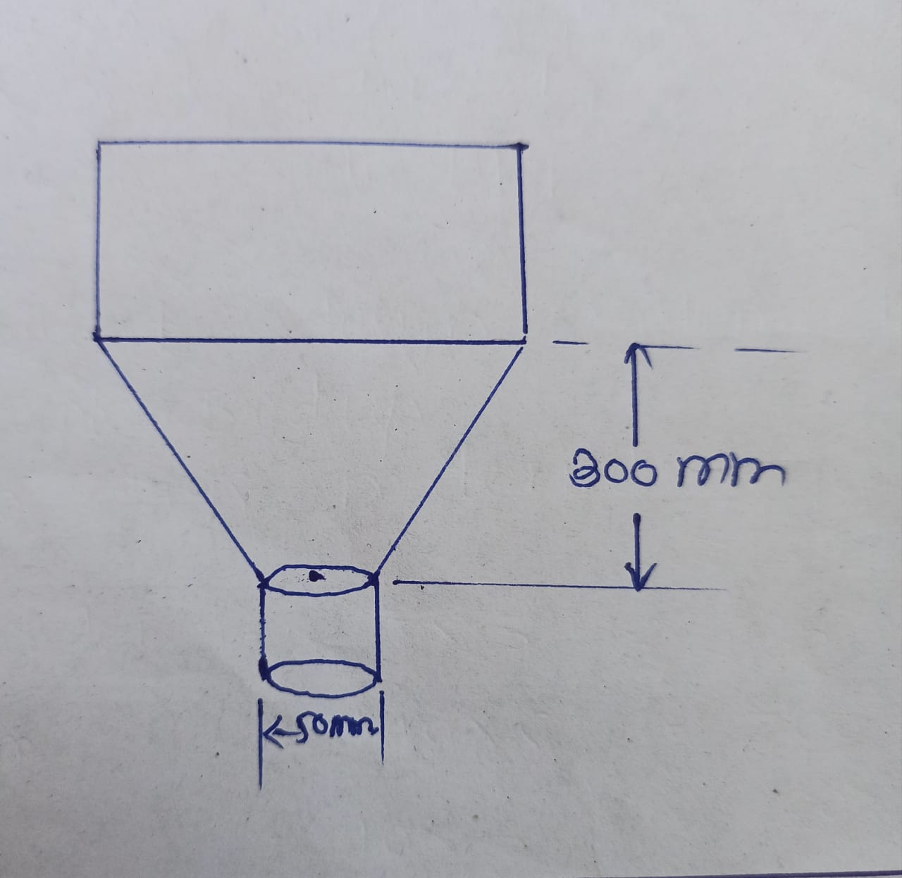
The volume of Al powder divided into 2 part
i cylinder
ii) Cone
but we have decided from total volume two third portion will be in the cone/frustum Volume of Al power= 0 013 x 2 /3
= 8 67 x 10-3 m3
Volume of frustum is formula.
V = 3.14/3 (R²+r² + Rr)
Given
Y = 25mm = 0 025 m
h = 300 mm = 03 m
R = 2
V = 3.14/3 h ( R² + r*2+ Rr).
867x10-3 =3.14/3 X 0.3(R²+ (0:025)² + 0025 R)
R = 0 .152 m
R = 152 mm
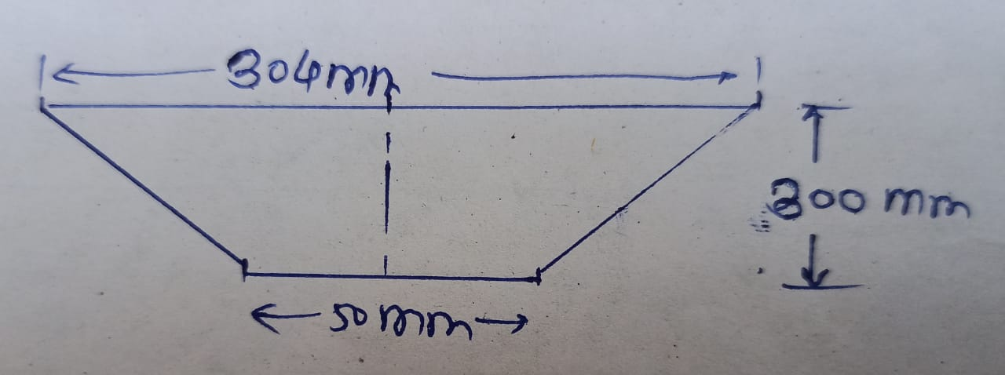
volume of Cylinder in remaining ore of volume of Al. powder is
Volume of cylinder = Ar³h
but we have restricted height is 300 mm 3-14 x (0.152)2 x 0.3
V = πr²h
V = 0·021 m3
Hence calculated volume is larger then required. So we have use fixed dimension
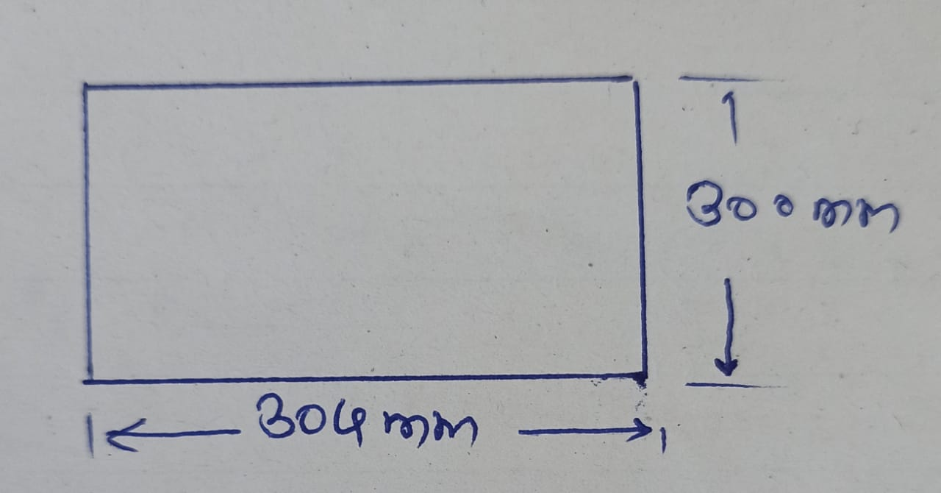
Final dimension of hopper of al powder is
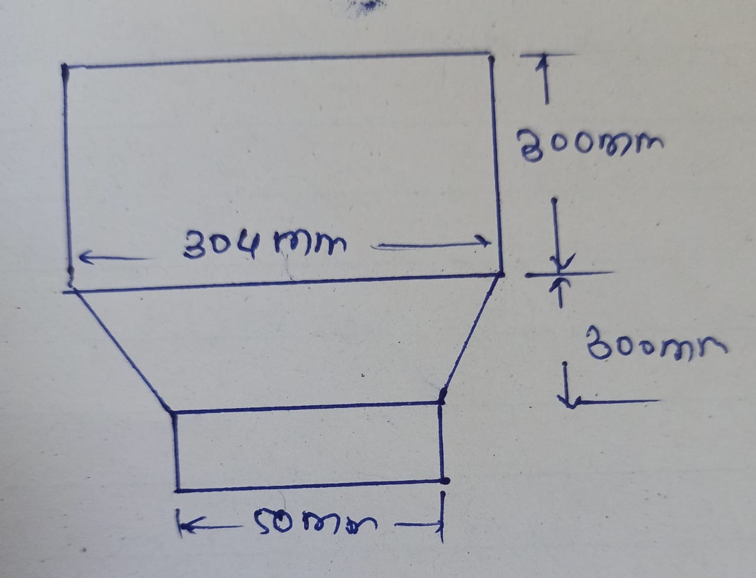

Design calculation for (gypsum hopper)
Given
density of gypsum is 2960 kg/m³ required storage capacity is 700 kg
M = 700 kg 8 = 2960 kg/m³
Volume = Mass/ density
V = M.
V = 700/ 2960
V= 0235 m*3
The volume of gypsum powder divided in 2 part
- Cylinder
- Cone
But we have decide from total volume of two third portion will be frustum
volume of gypsum in frustum of cone 2/3 is
0.23 x 2/3=0.15m3
volume of frustum of Cone = 3.14/3 h(R² + r² + Rr)
given
h = 500 mm = 0.5m
r = 0.05

V = 3.14/3 h( R² +r² + Rr)
0 15 = 3.14/3 X 0,5 ((0.05)² + R ² + 0 .05R)
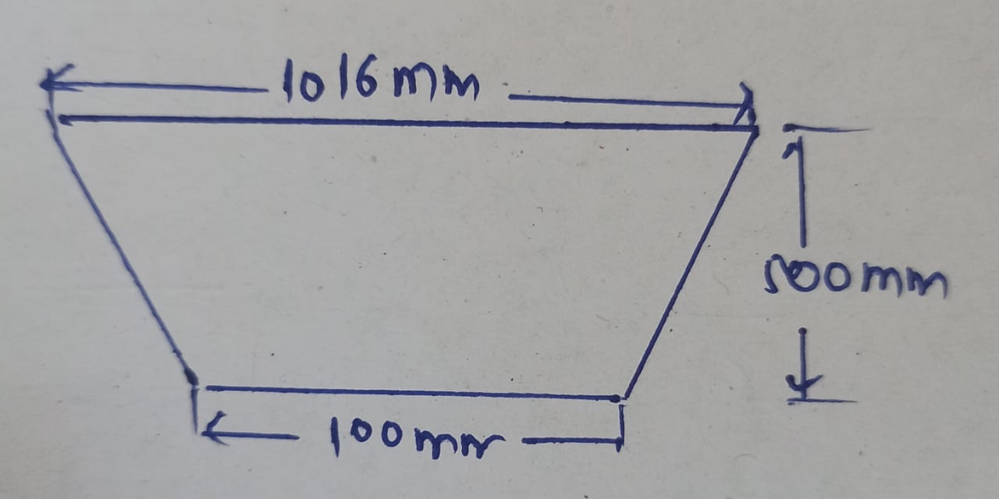

volume of Cylinder is
V = 1/3 X total volume
V= 1/3 X 0.23 = 0.076
volume of cylinder=3.14 r*2h
=3.14x (0. 508)*2 X 0.5
=0.24
calulated volume is larger than required volume So we used to fixed dimension
final dimension
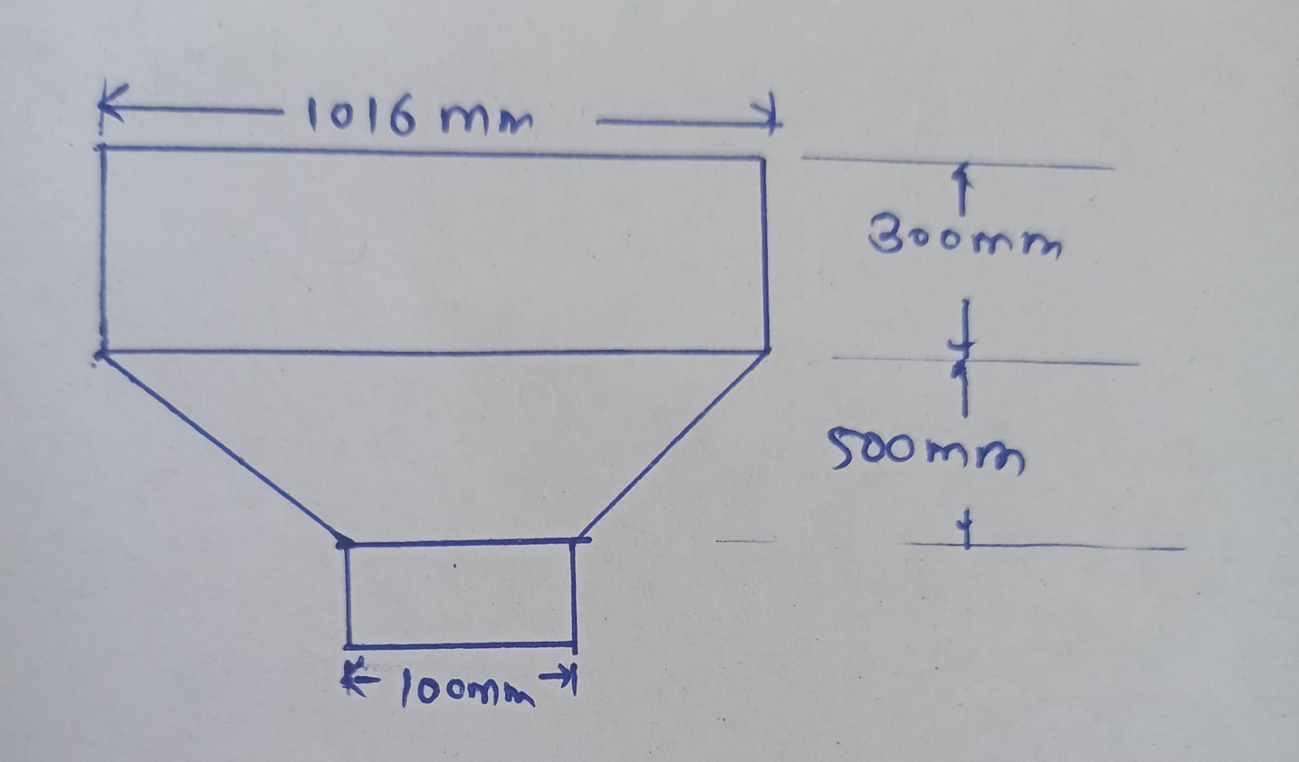

Design Calulation for storage for 50lit Soluble oil
Density of oil is 870 kg/m³
volume = mass /density
given
density= 870 kg/m³
v = 50 /870 = 0.057 m³
volume of cylinder but restricted height is 500 mm
V= πr²h
0.057 = 3.14 x r² x 0.5
r = 0.190 m
r = 190 mm
Final dimension:
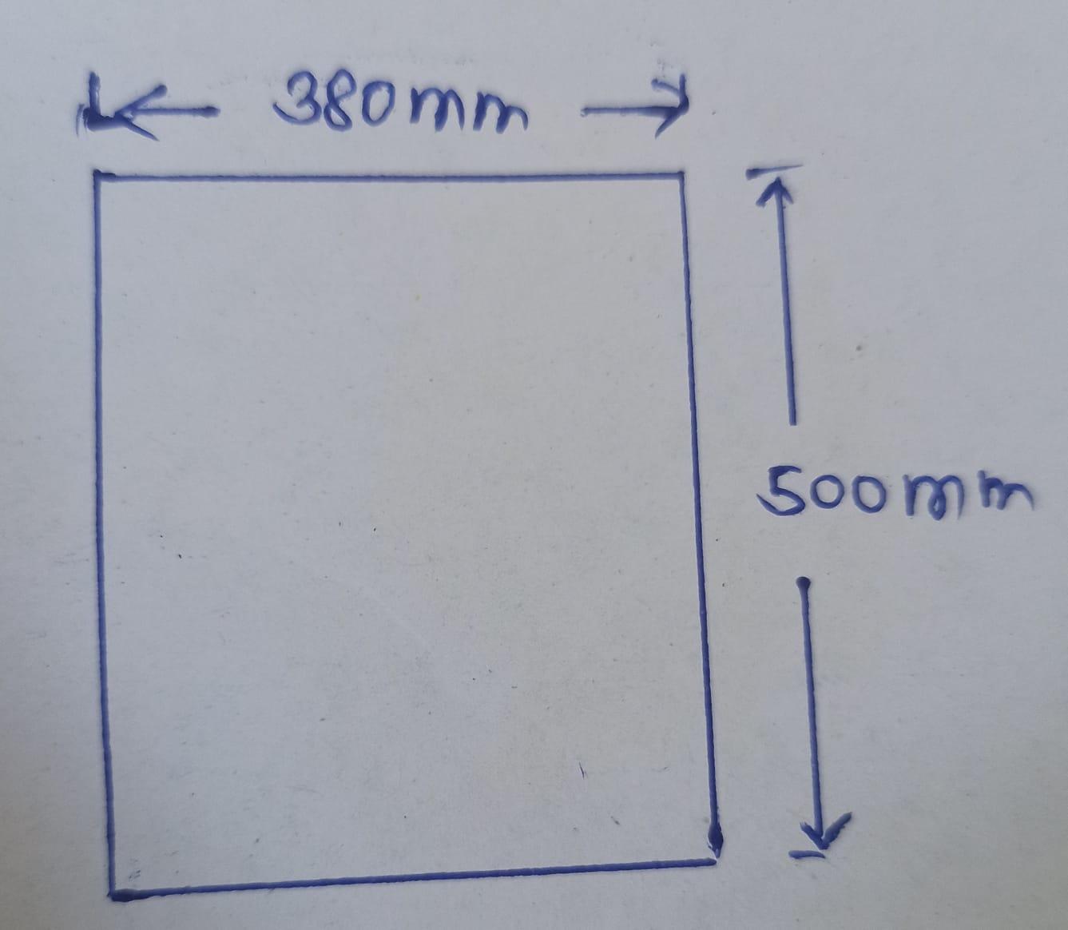

Design data:
Fig.1.

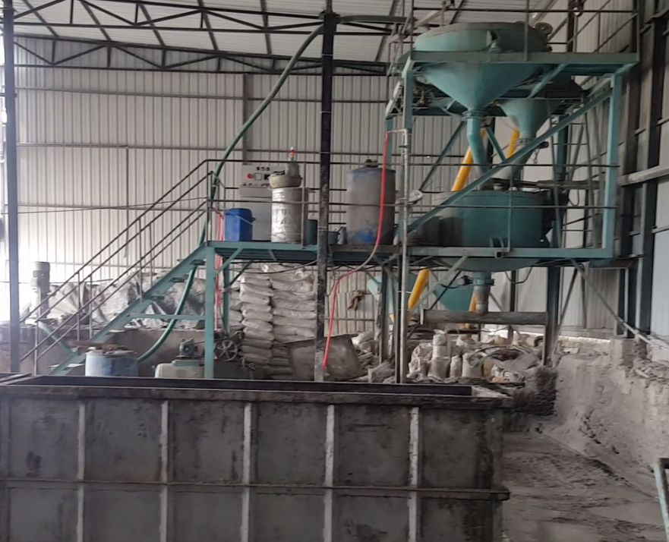
Currnt system of batching (mixing) plant
1.D 1500mm slurry hopper
2. D 1000mm cement & lime hopper
Fig.2.
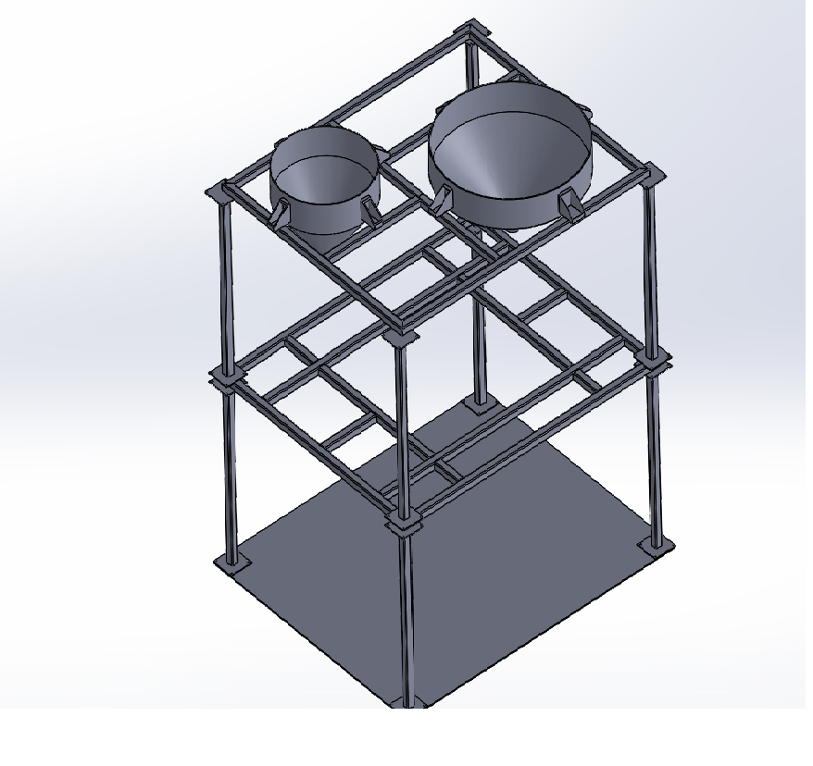

Design data:
Design hopper for storage of 35 to 40kg aluminum powder
Volume for 35 kg storage al powder is 0.13cb m.
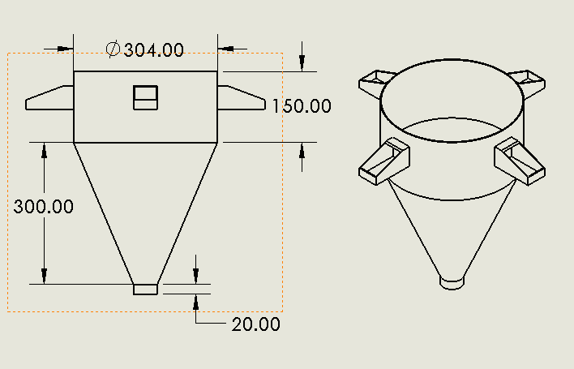 fig .3 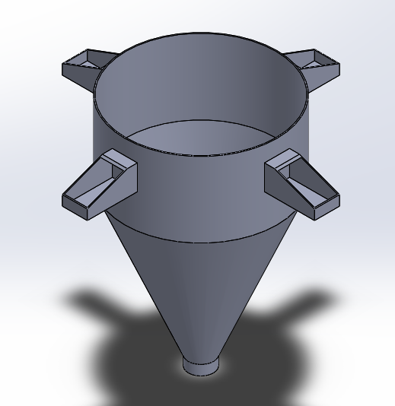

Design hopper storage of 700 to 750 kg gypsum powder
Volume for 700kg storage of gypsum powder is 0.23cbm

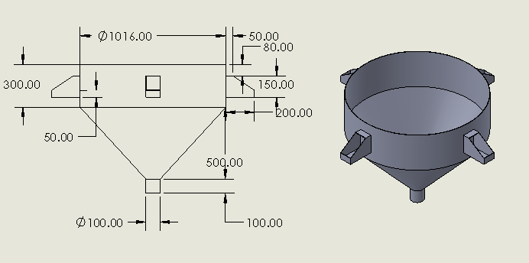 fig.4.

Design data:
50 lit capcity storage tank of soluble oil.
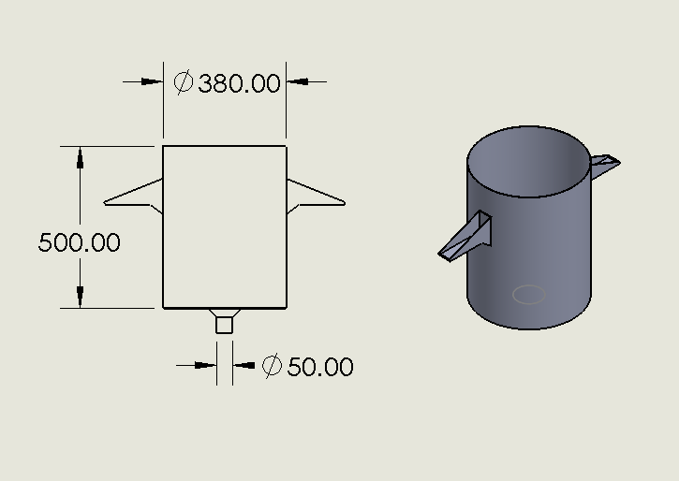 fig .5.
Design of cylindrical flask for proper al &gypsum content
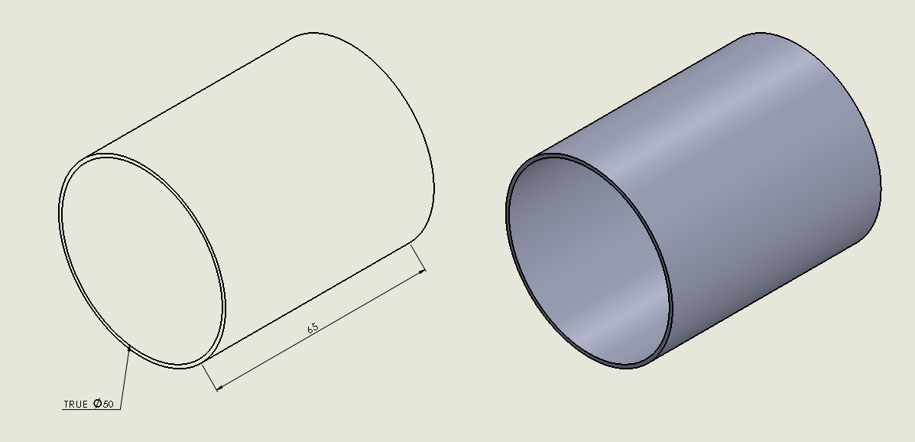 fig.6.
350 gm capacity flask of al powder.
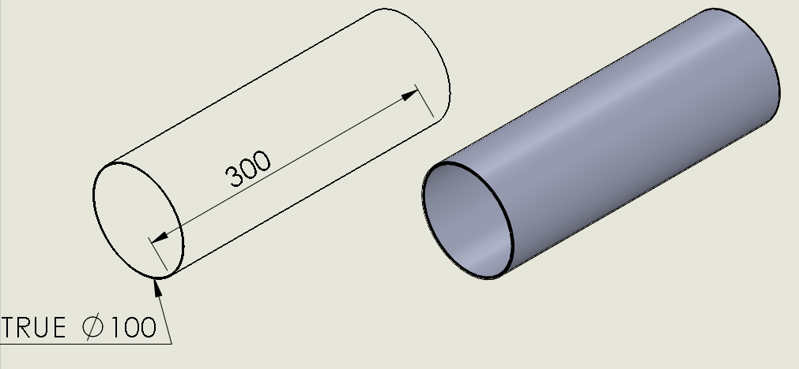 fig.7.
7kg capacity flask of gypsum powder

CHAPTER 4
Electrical actuators and control panel system
1. Sliding valve
2. Solenoid valve
3. Control panel system
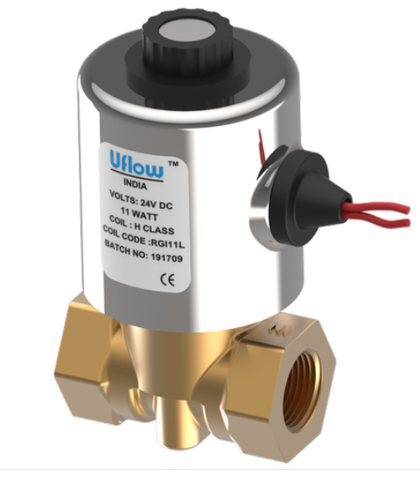
Solenoid valve: Solenoid valves are control unit which electrically energized or de-energized ,either shut off or allow fluid flow. its works by producing an electromagnetic field around a movable core called Armature it s opens and closes valves or switches and turn electrical energy into mechanical energy.

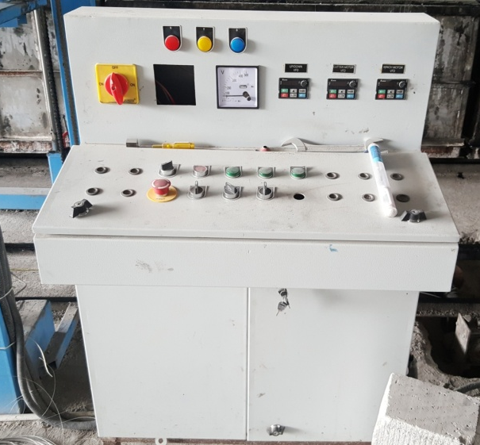
Control panel system: Control panel is an enclosure ,typically a metal box or plastic moulding which contains important electrical components that control and monitor a number of mechanical process.

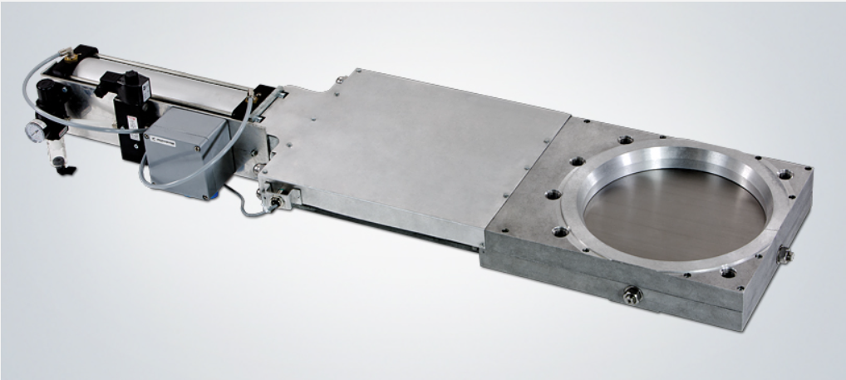
Sliding valve: Sliding valves that opens and close a passageway by sliding over a port specially such a valve often used in steam engines for admitting steam to the piston and release it.

Final View of Project

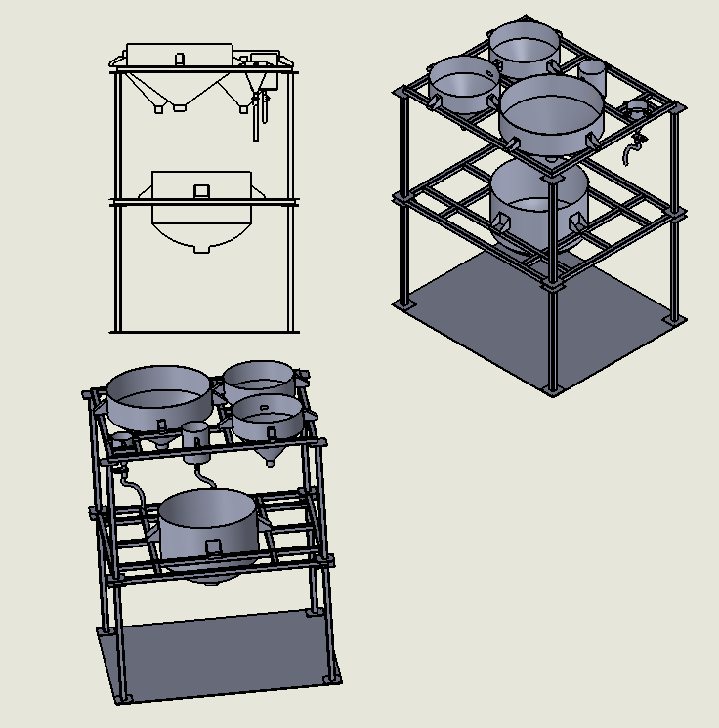
Fig.8

CHAPTER 5
CONCLUSION:
- Reduce cycle time of batching system hence increase in productivity of overall system
- Reduce the human interaction with the system hence failure in production or in recipe will be lesser.
- We can achieve desire strength repeatedly.
- Initial investment is little high but by considering this project for long term, it will always on beneficial side.

CHAPTER 6
REFERENCES:
[1]. Andrzej, M Pawlak, “Sensor and Actuator in Mechatronics Design and Applications,” (2006).
[2]. Balarama, V.Murty, “A New Approach for The Analysis Of Dynamic Behavior Of Solenoid Actuators With Time Dependent Voltage Input,” (1990).
[3]. Baek-Ju Sung, Eun-Woong Lee and Jae-Gyu Lee, “A design method of solenoid actuator using empirical design coefficients and optimization technique,” pp. 305-34, (2007).
[4]. Cedrat Technologies, “Non linear magnetic actuators,” Version 1.1, (2007).
[5]. D.Howe, “Magnetic actuators,” Sensors and Actuators, Vol. 81, pp.268–274, (2000).
[6] PASSARINI L C, NAKAJIMA P R. Development of a high-speed solenoid valve: an investigation of the importance of the armature mass on the dynamic response[J]. Journal of the Brazilian Society of Mechanical Sciences and Engineering, 2003, 25(4): 329–335.
[7] ILLYEONG LEE. Switching response improvement of a high speed on/off solenoid valve by using a 3 power source type valve driving circuit[C]//Proceedings of the IEEE International Conference on Industrial Technology, Mumbai, India, December 15–17, 2006:1823–1828.
[8] KAJIMA TAKASHI, KAWAMURA YOSHIHISA. Development of a high-speed solenoid valve: investigation of solenoids[J]. IEEE Transactions on Industrial Electronics, 1995, 42(1): 1–8.
[9] MUTAI H, YAMASAWA K. Fundamental operations of a multi-polar disk-solenoid[J]. IEEE Transactions on Magnetics, 1995, 31(4): 2445–2449.
[10] SEILLY A H. Helenoid actuators-a new concept in extremely fast acting solenoids[C]//SAE Congress and Exposition, Detroit, USA, February 26–March 2, 1979: 426–435
[11] P. Vidal,E. Gallego,M. Guaita,F. Ayuga.,“Finite element analysis under different boundary conditions of the filling of cylindrical steel silos having an eccentric hopper Journal of Constructional Steel ”,Research 64 (2008) 480-492.
[12] D. Briassoulis, “Finite element analysis of a cylindrical silo shell under unsym- metrical pressure distributions Computers andStructures”, 78 (2000) 271-281
[13] Y.Zhao, J.G.Teng, “Buckling experiments on steel silo transition junctions I: Experimental results”, Journal of Constructional Steel, Research 60 (2004) 1783-1801
[14] Y. Zhao, J.G. Teng,“Buckling experiments on steel silo transition junctions II: Finite element modelling ”, Journal ofConstructional Steel Research 60 (2004)1803-1823
[15] F.ayuga, P.agudo, E.gallego, A.ramirez “New steps towards the knowledge of silos behaviour”, Int. Agrophysics, 2005,19,7-17
[16] FuatTinis,Fatih Bazman,“Stiffening of thin cylindrical silo shell against buckling loads. ”, Industrial plant manufacturing and erection corp, 06791, turky-2006
[17] C.Y. Song,“Effect of patch loads on structural behaviour of circlar flat bottom stell silo ”, Thin-Walled Structures 42 (2004) 1519-15
[18] Brunete A, Hernando M, Gambao E (2004) Drive modulesfor pipe inspection microrobots. In: International conference onmechatronics and robotics
[19] Ono M, Hamano T, Kato S (2002) T-3-3-2 development of anin-pipe inspection robot movable for a long distance. Proc AsianConf Multibody Dyn 2002:255–258. https://doi.org/10.1299/jsmeacmd.2002.255
[20] Pearce M (2005) Is there an alternative to fluid power?[electrically driven linear motion technology]. Comput ControlEng J 16(2):8–11. https://doi.org/10.1049/cce:20050201
[21] Richer E, Hurmuzlu Y (2000) A high performance pneumaticforce actuator system: Part i-nonlinear mathematical model.Transactions-American Society of Mechanical Engineers Journal
of Dynamic Systems Measurement and Control 122(3):416–425
[22] Richer E, Hurmuzlu Y (2000) A high performance pneu-matic force actuator system: Part ii-nonlinear controller design.Transactions-American Society of Mechanical Engineers Jour-nal of Dynamic Systems Measurement and Control 122(3):426–434
[23]29 IS 2185,PART 3 1984,specification for concrete masonery units, Autoclaved cellular(aerated) Concrete blocks.
[24] P.S.Bhandari, Dr. K.M.Tajne, Cellular Lightweight Concrete Using Fly Ash, International Journal of Innovative Research in Science, Engineering and Technology,Vol. 3, Issue 11, November 2014.
[25] Ashish S. Moon, Dr. Valsson Varghese , S. S. Waghmare, Foam Concrete as A Green Building Material, INTERNATIONAL JOURNAL FOR RESEARCH IN EMERGING SCIENCE AND TECHNOLOGY, VOLUME-2, ISSUE-9, SEP-2015.
[26] S. Nandi, ArnabChatterjee, PrantikSamanta, TanushreeHansda, Cellular Concrete & its facets of application in Civil Engineering, International Journal of Engineering Research ISSN:2319-6890(online),2347-5013(print),Volume No.5, Issue Special 1 pp : 37-43 8 & 9 Jan 2016.
[27] FunsoFalade, EfeIkponmwosa, Bright Ukponu, The Potential of Laterite as Fine Aggregate in Foamed Concrete Production, Civil and Environmental Research ISSN 2224-5790 (Paper) ISSN 2225-0514 (Online)Vol.3, No.10, 2013
[28] IS-875 (Part 1):1987 – “Dead Loads on Buildings and Structures” – Bureau of Indian Standards, New Delhi, India.
[29] IS-456:2000 – “Plain and Reinforced Concrete – Code of Practice” – Bureau of Indian Standards, New Delhi, India.
[30] IS-875 (Part 2):1987 – “Live Loads on Buildings and Structures” – Bureau of Indian Standards, New Delhi, India.

